SIMATS ENGINEERING (SAVEETHA SCHOOL OF ENGINEERING) Department of Computer Science and Engineering
ASSESSMENT TOOL 3 – DEBUGGING & OPTIMISATION TASK
Course Code: | CSA06 | Course Title: | Design and Analysis of Algorithms
CO Assessed: | CO2 – Manipulation (BL1, BL2, BL3) | Assessment: | Assessment Tool 3 – Debugging & Optimisation Task
Weightage: | 10% of CIA | Total Marks: | 100
CO2 Statement: | Apply Brute Force technique to solve sorting, searching, Closest-Pair and Convex-Hull problems (BL1, BL2, BL3)
Student Name: | R.Poojitha | Reg. No.: | 192311255
Section / Batch: | CSE | Date:

Instructions to Students
• Answer the following question. Total Marks: 100.
• Carefully analyze the given program/code segment before identifying errors.
• Clearly identify logical, syntactical, and performance-related issues in the code.
• Apply systematic debugging techniques to correct the errors effectively.
• Optimize the given solution by improving efficiency, reducing unnecessary computations, or enhancing time complexity wherever possible.
• Provide proper justification for all corrections and optimization decisions.
• Write clean, structured, and well-documented code with appropriate comments.
• Maintain clarity, logical reasoning, and technical accuracy throughout the solution.

Question Type | Focus Area | Questions
Debugging &  Optimisation Task | Identify errors, debug programs, and optimize algorithm efficiency using appropriate techniques | Q1

SECTION A – DEBUGGING & OPTIMISATION TASK

Code of Conduct
I P Sanjeev / 192324231 (Name / Reg No) certify that this submission is my original work and that I have adhered to the guidelines specified for this assessment. I understand that any violation of academic integrity rules will result in disciplinary action.
Signature of the Student: _________________________

RUBRICS FOR CALCULATION
Criteria | Wt. | Level 4 – Exemplary | Level 3 –  Proficient | Level 2 –  Developing | Level 1 –  Beginning
Problem  Identification | 20% | Accurately identifies all errors and root causes with clear understanding | Identifies most  errors with minor gaps | Identifies some  errors but misses key issues | Unable to identify errors correctly
Debugging | 25% | Applies systematic  debugging techniques effectively to resolve  issues | Uses appropriate debugging  methods with  minor errors | Limited debugging approach; requires guidance | Unable to debug or resolve issues
Optimization | 20% | Optimizes code by  significantly improving time complexity using efficient algorithms | Improves time  complexity with  minor gaps in  efficiency | Limited  improvement in  time complexity | No improvement; inefficient  approach retained
Analysis | 20% | Demonstrates strong  logical reasoning and clear justification of  solutions | Shows reasonable analysis with some justification | Limited analysis;  weak reasoning | No analytical  reasoning  demonstrated
Code Quality | 15% | Produces clean, well  structured code with  proper comments and documentation | Code is mostly  clear with minor  documentation  gaps | Code lacks  structure and  proper  documentation | Poorly written  code with no  documentation

Marks Evaluation:
Criteria | Wt. | Level 4 –  Exemplary | Level 3 –  Proficient | Level 2 –  Developing | Level 1 –  Beginning
Problem Identification | 20%
Debugging | 25%
Optimization | 20%
Analysis | 20%
Code Quality | 15%
Total Marks (100):

Faculty In-charge | Course Coordinator | Head of Department
Name: | Name: | Name:
Signature: _______________ | Signature: _______________ | Signature: _______________
Date: ___________________ | Date: ___________________ | Date: ___________________

1st Question:
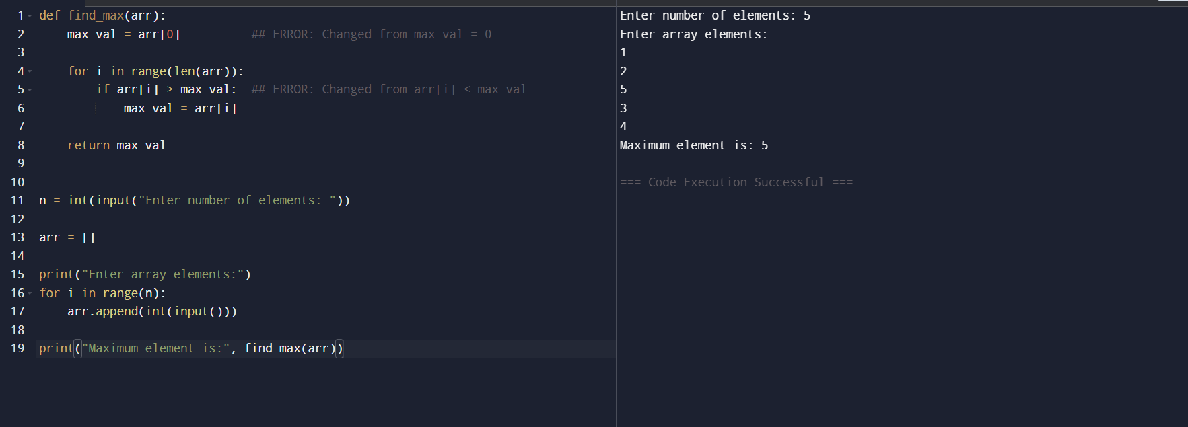

2nd Question: 